AEP Span Panel Finish Indicator - Mini-V-Beam
CUSTOMERS NOTE: This form must be completed, signed and returned to your AEP Span Customer Service Representative.
YOUR ORDER WILL NOT BE PRODUCED WITHOUT THIS FORM COMPLETED
Customer Name
Todays Date
Project Name
SO #
Mini-V-Beam
I am using this panel as a
(Indicate)

Wall Roof

I expect the paint to be on this side

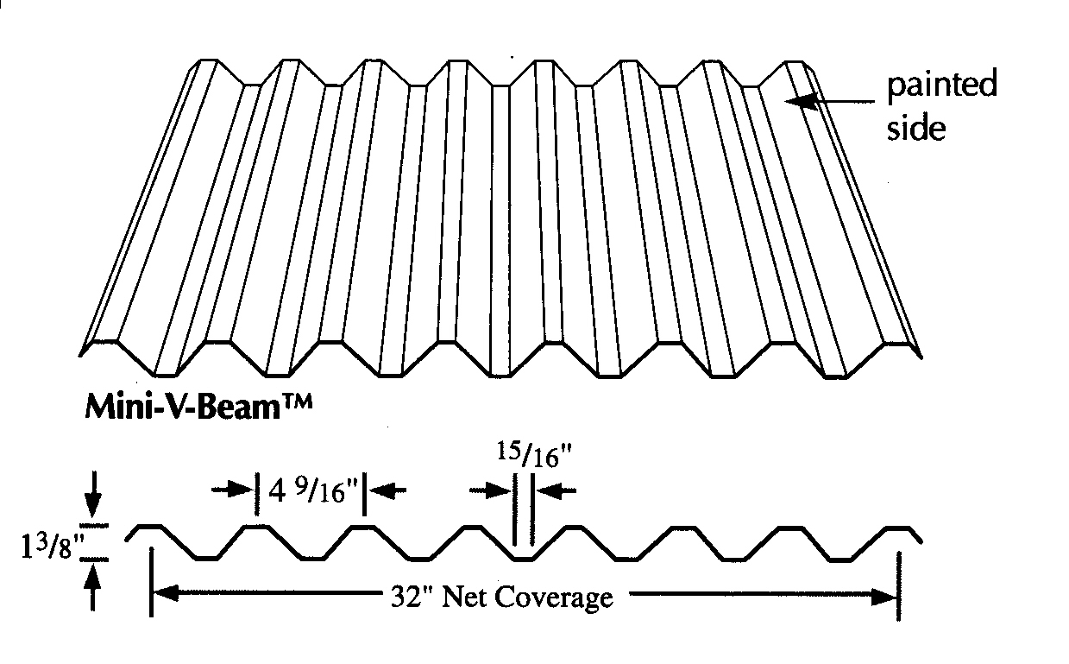
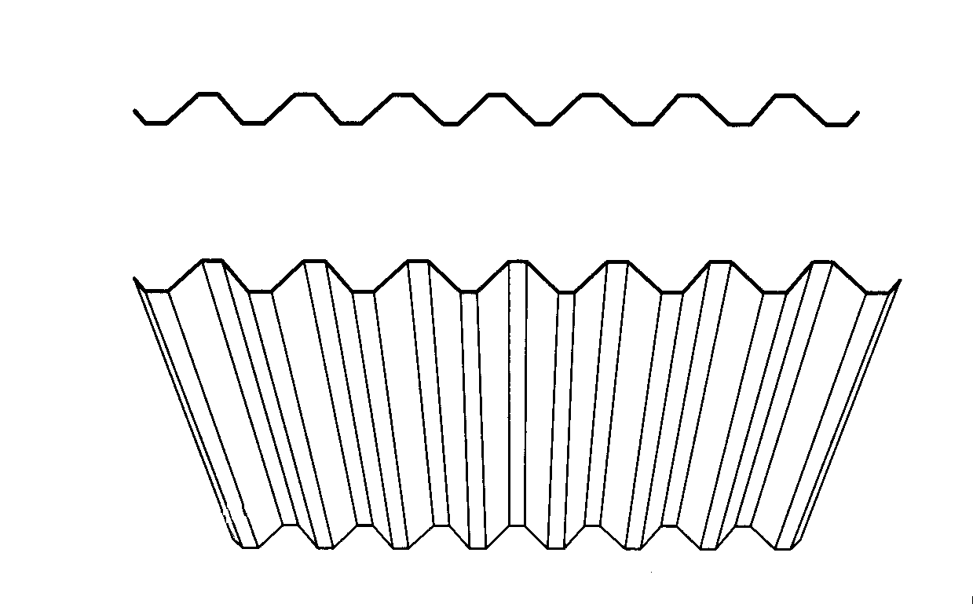
Reverse
Mini-V-Beam

This profile is for
WALLS ONLY

I expect the paint to be on this side

painted side

