Perception Collection® is a family of five 12” wide, asymmetrical ribbed, metal panels for walls, fascias, and equipment screen applications. The uniquely shaped ribs provide an aesthetically pleasing appearance and ever-changing shadow lines. These panels can be used in either horizontal or vertical applications. The panel’s concealed fastener system provides a clean look in any application.
This Guide Specification is to be used to develop an office master specification or specifications for a project. Edit this guide specification to meet project requirements. Coordinate with other specification sections as required.
Document Coordination: For projects using several profiles, rib patterns, or finishes, schedule panels in this section or in Drawings. Indicate flashing, trim, and closures in Drawings; details are available on AEP Span's web site. Edit "Architect" to reflect the title of the design professional of record.
SECTION 07 42 13 – METAL WALL PANELS
- GENERAL
      - SUMMARY
        - Section includes complete system of concealed-fastener, lap-seam metal panels in the following applications:
          - Metal wall panels.
Edit list of related sections for project requirements. Section numbers and titles are those recommended in CSI MasterFormat; revise numbers and titles to reflect actual sections in Project Manual.
        - Related Requirements:
          - Section 05 10 00: Structural Metal Framing.
          - Section 05 40 00: Cold-Formed Metal Framing.
          - Section 05 50 00: Metal Fabrications.
          - Section 07 21 00: Thermal Insulation.
          - Section 07 26 00: Vapor Retarders.
          - Section 07 92 00: Joint Sealants.
          - Section 09 81 00: Acoustic Insulation
      - REFERENCES
        - Reference Standards:
          - ASCE 7: Minimum Design Loads for Buildings and Other Structures.
          - ASTM A653: Steel Sheet, Zinc Coated (Galvanized) or Zinc Iron Alloy Coated (Galvannealed) by the Hot Dip Process.
          - ASTM A792: Steel Sheet, 55 % Aluminum Zinc Alloy Coated by the Hot Dip Process.
          - ASTM C1371: Determination of Emittance of Materials Near Room Temperature Using Portable Emissometers.
          - ASTM C1549: Determination of Solar Reflectance Near Ambient Temperature Using a Portable Solar Reflectometer.
          - ASTM D523: Specular Gloss.
          - ASTM E283: Rate of Air Leakage Through Exterior Windows, Curtain Walls, and Doors Under Specified Pressure Differences Across the Specimen.
          - ASTM E331: Water Penetration of Exterior Windows, Skylights, Doors, and Curtain Walls by Uniform Static Air Pressure Difference.
          - ASTM E1592: Structural Performance of Sheet Metal Roof and Siding Systems by Uniform Static Air Pressure Difference.
          - ASTM E1918: Measuring Solar Reflectance of Horizontal and Low Sloped Surfaces in the Field.
          - ASTM E1980: Calculating Solar Reflectance Index of Horizontal and Low Sloped Opaque Surfaces.
          - CRRC-1 Method #1: Measuring Solar Reflectance of a Flat, Opaque, and Heterogeneous Surface Using a Portable Solar Reflectometer.
          - SMACNA Architectural Sheet Metal Manual.
      - SUBMITTALS
        - Product Data.
        - Shop Drawings:
          - Indicate thickness and dimensions of parts, fastenings and anchoring methods, details and locations of joints, transitions and other provisions necessary for thermal expansion and contraction.
          - Indicate locations of field- and factory-applied sealant.
        - Samples:
          - Submit two samples, 12 inches long by full panel width, showing proposed metal thickness and seam profile.
          - Submit standard color samples of metal for Architect’s selection.
        - Manufacturer Qualifications.
        - Installer Qualifications: Submit list of completed projects, with names and contact information for architects and contractors.
        - Test Reports: Indicating compliance of products with project requirements.
Delete LEED Submittals paragraph and subparagraph below if Recycled Content credit is not required for project. Credit is based on LEED 2009 NC, Schools, and CS rating systems.
Perception Collection® may support additional credits that do not require LEED submittals demonstrating compliance of metal panels. One such credit is LEED Credit EA Credit 1 – Optimize Energy Performance: cool-pigment finishes reduce heat gain, so may reduce overall building energy use.
        - LEED Submittals: LEED Credit MR 4 – Recycled Content: Product data indicating percentage by weight of post-consumer and post-industrial recycled content for products having recycled content. Include statement indicating costs for each product having recycled content.
        - Warranty Documentation.
        - Insurance Documentation.
      - QUALITY ASSURANCE
        - Manufacturer Qualifications:
          - Ten years' experience, minimum, in factory fabrication of metal panels.
          - Manufacturer shall carry $2,000,000 liability insurance, minimum, for metal panel system.
        - Installer Qualifications:
          - Three years' experience, minimum, in application of metal roof or wall panels.
          - Five satisfactory projects with metal panel work of similar scope and complexity to Work of this Project.
        - Product Testing Agency Qualifications: Agency compliant with ISO/IEC Standard 17025, or an accredited independent agency recognized by the International Laboratory Accreditation Cooperation Mutual Recognition Arrangement or ANSI.
Generally delete requirement for mock-ups. Two instances where metal panels may be required in mock-ups are shown below; retain applicable requirements and edit to suit Project.
        - Mock-Ups:
          - Visual Mock-Up: Construct mock-up, 10 by 10 feet or larger as required to show at least two pattern repeats, and in same orientation as [entrance facade] [facade designated by Architect] <Insert location>.
          - Performance Mock-Up: Construct metal panel system as required for Performance Mock-Up specified in [Section 01 43 39 "Mock-Ups"] <Insert section>.
      - DELIVERY, STORAGE, AND HANDLING
        - Storage and Handling Requirements:
          - Keep panels and accessory items dry.
          - Protect against damage and discoloration.
          - Handle panels with non-marring slings.
          - Support panels to prevent permanent deformation.
          - Store panels above ground, with one end elevated for drainage.
          - Protect panels against standing water and condensation between adjacent surfaces.
          - If panels become wet, immediately separate sheets, wipe dry with clean cloth, and keep sheets separate for air-drying.
          - Painted panels shall be shipped with protective plastic sheeting or a strippable film coating between panels. Remove strippable film coating prior to installation. Do not allow strippable film coating to remain on panels in extreme heat, cold, or direct sunlight or other UV source.
      - WARRANTY
For projects less than 1320 feet (1/4 mile) from salt water or industrial or other corrosive applications, consult your AEP Span Representative. A high-build primer of 0.8-1.2 mils or other coating system may be recommended.
        - Manufacturer's Warranty: Manufacturer’s standard 25-year performance warranty, stating the following:
          - Architectural fluorocarbon finish:
            - Will be free of fading or color change in excess of 5 Hunter delta-E units as determined by ASTM D2244-02.
            - Will not chalk in excess of numerical rating of 8 when measured in accordance with standard procedures specified in ASTM D4214-98 method D659.
            - Will not peel, crack, chip, or delaminae.
          - Metal substrate will not rupture, fail structurally, or perforate.
        - Installer's Warranty: Warrant panels, flashings, sealants, fasteners and accessories against defective materials and/or workmanship, covering repairs required to maintain wall panels watertight and weatherproof with normal usage for two years following Project Substantial Completion date.
          - Furnish written warranty, signed by installer.
- PRODUCTS
      - SYSTEM DESCRIPTION
This guide specification demonstrates how to specify the Perception Collection® panels by AEP Span. If a competitive specification is required, add additional manufacturers and retain the option in the paragraph below.
        - Products: Provide the following:
          - AEP Span, a Division of ASC Profiles LLC.; Perception Collection®.
Select one of two options below. If listing multiple manufacturers above, chose first option. If choosing second option, edit section number and title to match actual Division 01 section where substitutions are controlled.
        - Substitution Limitations: [Substitutions will not be considered.] [Substitutions will be considered in accordance with Section 01 25 00 "Substitution Procedures".]
        - Performance Criteria
AEP Span tests its panels for wind uplift using ASTM E1592, which provides a rigorous evaluation for metal roof and wall panels. Some manufacturers publish data based on ASTM E330, a testing protocol for curtain wall assemblies.
Generally, do not specify both performance and panel thickness. If using performance method, consult structural engineer and edit below. For panel thickness method, see wind resistance tables for Perception Collection® at www.aepspan.com, delete paragraph below, and retain a thickness in "Panel" article.
          - Wind Uplift: [As required by [ASCE 7] <Insert governing code>] <Insert required load>
            - Panel system shall be ASTM E1592 tested under the supervision of an ANSI or ISO/IEC accredited laboratory and the laboratory shall issue the test report. Test data based on ASTM E330 is not acceptable.
            - Deflection Limits: Withstand wind loads with deflections no greater than [1/180] <Insert ratio> of the span.
Retain air infiltration and water penetration requirements for panels installed in wall applications. The Perception Collection complies with these requirements.
          - Air Infiltration: 0.01 cfm/lf, maximum at a static difference of 6.24 psf when tested with sidelap sealant per ASTM E283.
          - Water Penetration Under Static Pressure: No leakage at 20 psf when tested with sidelap sealant per ASTM E331.
          - Thermal Movements: Accommodate thermal movement without buckling, joint opening, failure of connections, or other detrimental effects, through the following temperature changes:
            - 120 degrees F, ambient.
            - 180 degrees F, surface.
      - PANELS
Perception Collection® concealed-fastener metal wall panels may be installed in either horizontal or vertical orientation. Standard lengths are 5 to 20 feet in 20, 22, and 24 gauge material.
        - Panel: AEP Span, a Division of ASC Profiles LLC; Perception Collection®
          - Material: Steel conforming to ASTM A792.
Select gauge according to AEP Span's performance tables, required span, and applicable loads. AEP Span recommends 22 gauge for enhanced structural performance and aesthetic appeal.
24 and 22 gauge panels are standard, and 20 gauge panels are non-standard. If panels are specified by performance, retain last subparagraph.
            - [24 Gauge][22 Gauge]: Yield strength 50,000 psi; with aluminum-zinc alloy coating conforming to ASTM A792, Class AZ50.
            - 20 Gauge: Yield strength 40,000 psi; with zinc coating conforming to ASTM A653, Class G 90.
            - Thickness and yield strength as required for performance indicated; with aluminum-zinc alloy coating conforming to ASTM A792, Class AZ50 or with zinc coating conforming to ASTM A653, Class G 90.
For projects with multiple combinations of finishes, use panel schedule at the end of Part 3 or show on Drawings.
          - Profile and Pattern: [As Scheduled.]
            - Perception Collection®, #PC10-12, 12” coverage, three 1-1/2” rib profile, 7/8” rib height

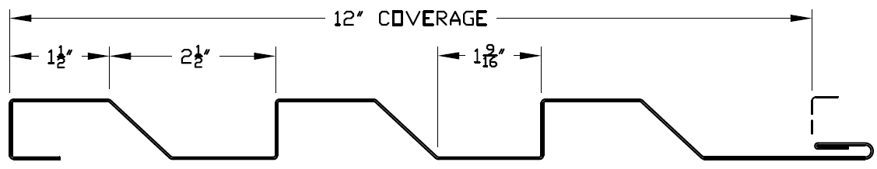

            - Perception Collection®, #PC20-12, 12” coverage, 1-1/2 + 5-1/2” rib profile, 7/8” rib height

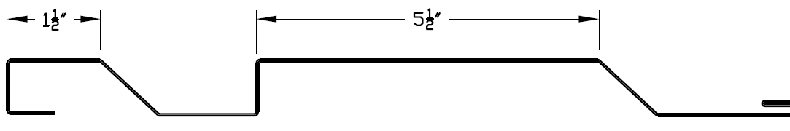

            - Perception Collection®, #PC30-12, 12” coverage, 5-1/2 + 1-1/2” rib profile, 7/8” rib height

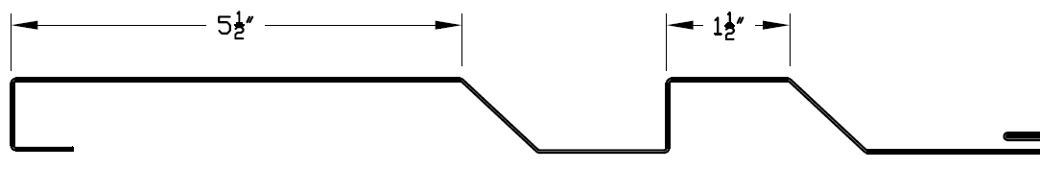

            - Perception Collection®, #PC40-12, 12” coverage, two 3-1/2” rib profile, 7/8” rib height

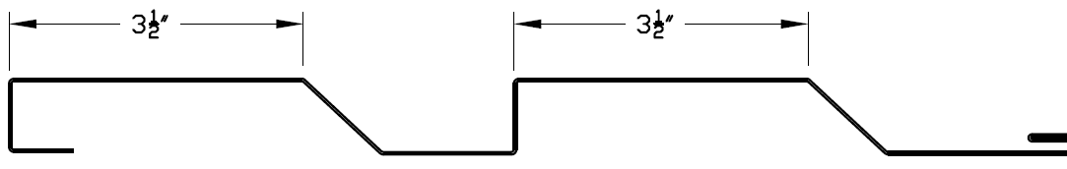

            - Perception Collection®, #PC50-12, 12” coverage, one 9-1/2” rib profile, 7/8” rib height

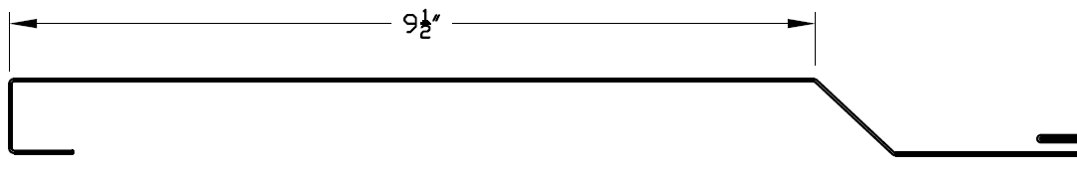

            - Panel to substrate attachment: [Clip Attached] [Direct Fastened]

If multiple finishes are required, retain applicable finishes and use panel schedule.
          - Finishes:
            - Exterior Panel Finish: Provide primer and finish coat on exposed faces; provide primer on concealed faces of panels.
Choose one or more of the following exterior finishes.
              - Dura Tech™ 5000: Polyvinylidine Fluoride, full 70 percent Kynar 500/Hylar 5000, consisting of a baked-on 0.15-0.20 mil corrosion resistant primer and a baked-on 0.70-0.80 mil finish coat with a specular gloss of 8 to 15 when tested in accordance with ASTM D523 at 60 degrees.
ZINCALUME® Plus is a thin, clear acrylic topcoat, recommended for uniform weathering of unpainted ZINCALUME panels.
              - ZINCALUME Plus protective coating for unpainted aluminum-zinc alloy coating.
              - Dura Tech™ mx metallic finish, consisting of a baked-on primer 0.15-0.2 mil and a baked-on Polyvinylidine Fluoride finish coat 0.70-0.80 mil with a specular gloss of 20 to 35 when tested in accordance with ASTM D523 at 60 degrees.
              - Dura Tech™ Specialty Finishes: Polyvinylidine Fluoride, full 70 percent Kynar 500/Hylar 5000, consisting of a baked-on corrosion resistant primer and a baked-on finish coat with a dry film thickness of 1.10 to 1.40 mil and specular gloss of 25 to 35 when tested in accordance with ASTM D523 at 60 degrees.
Custom colors are available on orders of 3,000 linear feet or more. Consult an AEP Span representative for additional information.
              - Exterior Panel Color: [As scheduled.][As selected from manufacturer's full range.]<Insert color.>
            - Interior Panel Finish: Corrosion-resistant primer; primer coat dry film thickness: 0.15 mils; polyester paint; dry film thickness of 0.35 mils, off-white to light gray in color.
        - Sustainability Characteristics:
The Perception Collection® panels in their standard sheet metal contain approximately 19.8 percent post-consumer recycled content and 14.5 percent pre-consumer recycled content, for a total 27 percent recycled content as calculated for this LEED credit. Higher percentages are available if specified.
          - Recycled Content: [27] [50] [75] percent post-consumer recycled content [Calculated according to LEED Credit MR 4].
          - Solar Performance:
            - Solar reflective index (SRI): Not less than [29][22]<Insert requirement> per ASTM E1980.
If "cool wall" reflective pigments are required, select SRI above or both characteristics below. In subparagraph above, first value is for DuraTech 5000 and DuraTech mx coatings; second value is for DuraTech Dimensional Prints. Check performance by color: some colors perform better than examples given.
            - Solar Reflectance: Not less than [0.25]<Insert requirement> per ASTM test methods C1549 or E1918, or CRRC-1 Method #1.
            - Thermal Emissivity: Not less than [0.75]<Insert requirement> per ASTM C1371.
          - Shipping Distance: Provide panels manufactured at the following factory:
If locally manufactured materials are a project requirement, select factory closer to Project site,
            - Fontana, California 92335
            - Anchorage, Alaska 99507
If project is subject to Federal Buy American provisions, retain paragraph below. AEP Span products comply with requirement.
        - Manufacturing Characteristics: Provide panels complying with provisions of Buy American Act 41 U.S. C 10a - 10d.
      - FRAMING AND SUBSTRATES
Edit framing and substrates to reflect Project requirements. Coordinate section numbers and titles.
        - Secondary Framing: See Section 05 40 00 "Cold-Formed Metal Framing".
        - Sheathing: See Section 06 16 00 "Sheathing".
        - Weather Barrier: See Section 07 25 00 "Weather Barriers".
Retain paragraph above or below, or delete both if neither weather barrier nor air barrier is required. AEP Span recommends the use of a weather barrier or air barrier behind Perception Collection® panels.
        - Air Barrier: See Section 07 27 00 "Air Barriers".
      - ACCESSORIES
Retain clip paragraph and subparagraphs below for applications utilizing clip attached panels vs direct fastened panels. Clips provide superior thermal movement characteristics compared to direct-fastened panel attachment. Panel clips are available as either flush mount or with a ½” standoff for rain screen applications.
        - Clip: Panel clip with pre-drilled holes attachment holes at one end and panel hook at other end, sized to fit panels.
          - Product: AEP Span; Perception Collection® [Flush Mount or ½” Stand-Off] Clip.
          - Material: 18 gauge (.0438 Min.), 40ksi yield min., G90 galvanized, material in conformance with ASTM A-653 Class G90.
          - Panel clips to be of proper design to resist uplift forces and reduce permanent deflection of panel assembly under design loads. Panel system manufacturer to provide proof that this has been addressed through use of clip strengthening ribs, short clip reach, or similar.
        - Trims and Flashings: Material, metal thickness, and finish to match panels. Profiles indicated in Drawings.
        - Panel Penetration Flashings: As recommended by panel manufacturer.
See Metal Construction Association Technical Bulletin "Fastener Selection".
        - Fasteners: Per manufacturer recommendation.
        - Profile Closures: Polyethylene foam, die-cut or formed to panel configuration.
        - Sealant for Field Application: See Section 07 92 00 "Joint Sealants".
        - Insulation: See Section 07 21 00 "Thermal Insulation".
        - Acoustic Insulation: See Section 09 81 00 "Acoustic Insulation".
      - FABRICATION
        - Fabrication, General:
          - Unless otherwise shown on Drawings or specified herein, fabricate panels in continuous lengths and fabricate flashings and accessories in longest practical lengths.
          - Panels shall be factory correctively-leveled.
        - Fabrication Tolerances:
See Metal Construction Association Technical Bulletin "Oil Canning" for more information. This bulletin is available at www.aepspan.com.
          - Flat metal surfaces will display waviness commonly referred to as “oil canning”. This is caused by steel mill tolerances and is a characteristic, not a defect, of panels manufactured from light gauge metal. Panels are factory correctively-leveled to minimize the occurrence of “oil canning”. As such, “oil canning” will not be accepted as cause for rejection.
- EXECUTION
      - EXAMINATION
        - Verification of Conditions: With Installer present.
          - Examine conditions and substrates on which metal panels are to be installed. Structural support or substrate shall be flat and plumb to avoid panel stresses and distortion.
          - [Verify that [air ][weather ]barrier work is complete and inspected.]
          - Prior to starting work, correct defects.
        - Field Measurements:
          - Coordinate field measurements and fabrication schedule with construction progress.
          - Field measure prior to fabrication. Show recorded dimensions on shop drawings, including locations of shop-fabricated openings.
          - If field measurements differ from drawing dimensions, notify Architect prior to fabrication.
        - [Framing][Substrate] Tolerances: Deviations from flat plane shall not exceed the following.
          - 1/4 inch in 20 feet vertically or horizontally.
          - 1/8 inch in 5 feet.
      - PREPARATION
        - Protection:
          - Treat contacting surfaces of dissimilar materials to prevent electrolytic corrosion.
          - Where panels or trim may come in contact with dissimilar materials or treated lumber, fabricate transitions to facilitate drainage and minimize possibility of galvanic corrosion.
          - At points of contact with dissimilar metal or treated lumber, coat panel or trim with protective paint or separate materials with a weatherproof underlayment.
          - Direct contact or run-off from CCA, ACQ, AC, or other treated lumber (outdoor wood) or fire retardant impregnated or treated wood shakes or siding can cause panels and trim to fail prematurely. Avoid contact with these materials.

      - INSTALLATION
        - [[Secondary Framing][Substrate and Air Barrier][Substrate and Weather Barrier]: Install according to approved shop drawings and metal panel manufacturer's recommendations.]
        - Panels and Flashing:
          - Install according to approved shop drawings.
          - Comply with methods and recommendations of SMACNA Architectural Sheet Metal Manual for flashing configurations required.
          - Overlap flashing at least 6 inches.
          - Discrepancies between job site conditions and shop drawings shall be brought to the attention of the Architect for resolution.
          - Cutting and Fitting:
            - Cut panels neat, square, and true with shearing action cutters. Torch or power saw cutting is prohibited.
            - Openings 6 inches and larger: Shop fabricate and reinforce to maintain original load capacity.
            - Openings less than 6 inches: Field cutting is acceptable.
        - Accessories: Install trims, panel closures, flashings according to Drawings and manufacturer's recommended details.
        - Sealant Installation: Apply according to approved shop drawings and SMACNA Architectural Sheet Metal Manual recommendations.
Generally, retain option in paragraph below and delete subparagraphs. If stringent installation tolerances are required, coordinate with requirements in specifications for framing or substrate to receive panels.
        - Installation Tolerances: [Match dimensional tolerances of framing or substrate.]
          - Flatness: <Insert requirement.>
          - Variation from Vertical: <Insert requirement.>
          - Variation from Level: <Insert requirement.>
      - CLEANING
AEP Span does not recommend touch-up painting of damaged surfaces (minor scratches, etc.) due to fading and weathering differences of the touch-up paints in comparison to factory applied paint systems.
        - Repairs:
          - Touch up paint is not required for panels with scratches that do not expose metal.
          - Panels or flashings with finish damage exposing metal or with substrate damage shall be replaced.
        - Cleaning and Waste Management: [See Division 01 Section "Construction Waste Management and Disposal" for recycling requirements.] At completion of each day’s work and at work completion, sweep panels, flashings, and gutters clean. Do not allow fasteners, cuttings, filings, or scraps to accumulate.
      - PANEL SCHEDULE
For projects with several combinations of finish, schedule panels below or in Drawings. If both horizontal and vertical panel orientations are required, indicate orientation in Drawings or add orientation to schedule. Panel descriptions in schedule below are examples only.

Panel Designation | Panel Designation | Finish | Ga | Color | Note
PC10-12 | Perception Collection, 3 x 1-1/2” rib profile | Specialty Finish | 22Ga | Burnt Rust | For use with standoff clip
PC40-12 | Perception Collection, 2 x 3-1/2” rib profile | Specialty Finish | 24Ga | Metallic Silver | For use with flush clip

END OF SECTION
ZINCALUME® is a registered trademark of BlueScope Steel Ltd.
Copyright 2016 by ASC Profiles LLC. Qualified design and construction professionals may copy for preparation of construction specifications. Issued August 2016.

